**What is Azure Synapse ?**

(Source: [doc](https://medium.com/microsoftazure/what-is-azure-synapse-e56f2a8b8d31#:~:text=Azure%20Synapse%20is%20a%20limitless%20analytics%20service%20that%20brings%20together,warehousing%20and%20Big%20Data%20analytics.&text=Azure%20Synapse%20brings%20these%20two,BI%20and%20machine%20learning%20needs.))

-Azure Synapse is a limitless analytics service.

-It brings together enterprise data warehousing and Big Data analytics.

-It gives you the freedom to query data using either server-less or provisioned resources at scale.

(A data warehouse is a type of data management system that is designed to enable and support business intelligence (BI) activities, especially analytics. Data warehouses are solely intended to perform queries and analysis and often contain large amounts of historical data.)

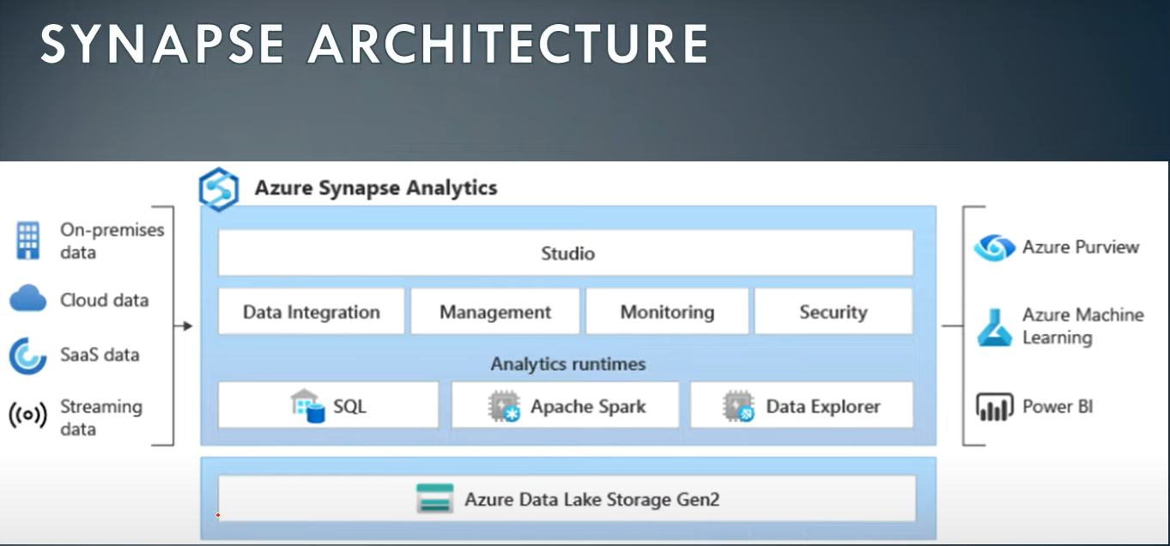

**Data Integrate:** To integrate/load data from various sources via -Pipelines -Copy data tool – Browse gallery -import from pipeline template

**Management:** To perform analysis via -SQL Pool(serverless & dedicated) -Spark – Data Explorer

(Serverless: cosmos db , azure storage(dl/blob), spark tables

Dedicated : A lot )

**Monitoring:** To monitor synapse solution/pipelines (i.e. how execution is going on ).

**Security:** To manage access, add role , give permissions to users.

**Key Service Capabilities**

(Source: [doc](https://azure.microsoft.com/en-in/services/synapse-analytics/#key-service-capabilities))

-Unified analytics platform

Perform data integration, data exploration, data warehousing, big data analytics and machine learning tasks from a single, unified environment.

-Serverless and dedicated options

Support both data lake and data warehouse use cases and choose the most cost-effective pricing option for each workload.

-Enterprise data warehousing

Build mission-critical data warehouse on SQL engine.

-Data lake exploration

Bring together relational and nonrelational data and easily query files in the data lake with the same service we use to build data warehousing solutions.

-Code-free hybrid data integration

Build ETL/ELT processes in a code-free visual environment to easily ingest data from more than 95 native connectors.

-Deeply integrated Apache Spark and SQL engines

Enhance collaboration among data professionals working on advanced analytics solutions. Easily use T-SQL queries on both your data warehouse and Spark engines.

-Log and telemetry analytics

Use industry-leading text-indexing technology to gain insights from time-series, log and telemetry data with the Azure Synapse data explorer distributed query engine.

-Choice of language

Use your preferred language, including T-SQL, KQL, Python, Scala, Spark SQL and .Net—whether you use serverless or dedicated resources.

-Integrated AI and BI

Complete your end-to-end analytics solution with deep integration of Azure Machine Learning, Azure Cognitive Services and Power BI.

-Cloud-native HTAP

Get insights from real-time transactional data stored in operational databases, such as Azure Cosmos DB, with a single click.